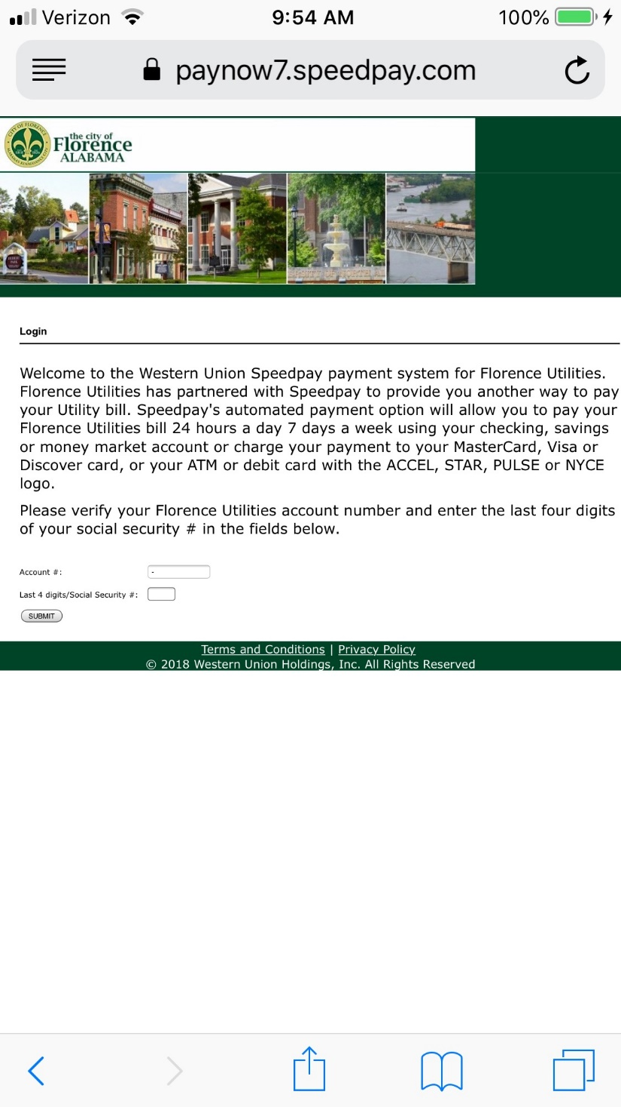Florence utilities Website

* The Florence utilities website is used for quick easy way to pay your utilities online.
* This is a good idea and lets people stay at home and don’t have to leave to go pay bills.
* The problem that I see with the Florence utilities website is the account number.
* I think that the account number shouldn’t be longer than four numbers as well. The website should let the customers put in the last four digits of the account number instead of multiple numbers.